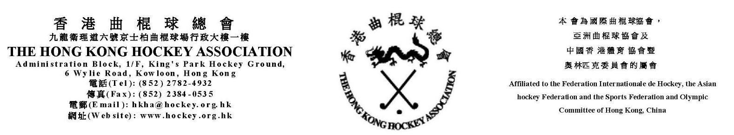

9th June 2020

Notice of the Annual General Meeting of the HKHAWS 2020

Notice is hereby given, in accordance with General Bye-Law 11.1 that the Annual General Meeting (AGM) of the Hong Kong Hockey Association Women’s Section (HKHAWS) will be held on Monday, 29th June 2020 at 7:30 p.m. in Hong Kong Football Club. The agenda for the meeting is attached and nominations are invited for the following posts:

- Chairwoman
- Vice Chairwoman
- Honorary Secretary
- Honorary Treasurer
- Ground & Fixtures Secretary
- General Committee Members (7)

The nomination on the attached specified Nomination Form, must be received by the HKHA office no later than 5pm Monday, 22nd June 2020. Valid nominations must be proposed and seconded by duly authorized officials of two different affiliated clubs and agreed to by the nominee. Late nominations will not be considered.

This is to remind all that Committee members should have attended at least sixty percent (60%) of the HKHAWS Committee meetings during their term of office or received approval from the current committee to stand for re-election.

Affiliated clubs may submit up to three (3) names as authorized representatives, who may attend the AGM. However, only one (1) has the power to vote. The authorized representative, so permitted to vote, shall personally sign the attendance register at the AGM. Please complete and submit the enclosed Attendance Form, which should reach the HKHA office no later than 5pm Monday, 22nd June 2020.

In order to ensure compliance with the legal restrictions currently in place due to covid-19, please note that the limit of three representatives per club must not be exceeded. Furthermore, on the day of the meeting the number of representatives present may need to be reduced further to ensure all clubs wishing to attend are represented.

Should any affiliated club have any other business to be considered in the AGM, please submit the notice in writing to the Hon. Secretary of HKHAWS together with the mentioned forms and nomination as above.
Affiliated Clubs are further reminded that the entitlement to vote at the AGM may be withdrawn if they have not settled all the outstanding fines and debts with the HKHAWS seven (7) days before the AGM. Please note that clubs with outstanding fee may also lose the entitlement to vote at the HKHA Council Annual General Meeting.
Yours sincerely,

Leena Madhvani
Hon. Secretary
HKHAWS

Distribution: Hon. Secretary General of HKHA
Hon. Secretary of each HKHA Section
All HKHAWS Committee members
Convenor of each club affiliated to the HKHAWS

